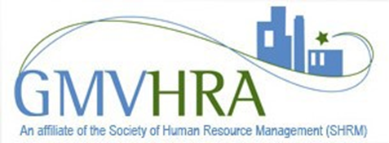

GMVHRA Non-Member Passes
One of GMVHRA's goals has been outreach to our community. That has taken place in many ways, for example, the work we have done with Salem High School and the Tierney Center in Boston. GMVHRA often has programs that will benefit those individuals who would not be included to join an organization such as SHRM but want and need some education in the human resources aspects of their business. For example, these could be small business owners or co-workers of GMVHRA members who are not in HR. To provide access to our programs, GMVHRA will be offering non-member passes. The cost of the passes is $35 a meeting or 3 meetings for $90 (a $15.00 savings). They can be used any meeting except the Legal Update or, if we have any, a special event which would be an additional cost to GMVHRA members.

